High Level Design

Issue 3.0

Team PT 4
1. AMARJEET BRIJNANDAN SINGH - A0150157M
2. ANKUR JAIN - A0148501M
3. CHENG HAO - A0006467E
4. GONG SHENGLIANG - A0112429M
5. HU RENWEN - A0150352U

© 2012-2016  The information contained in this document is the property of the Phoenix Radio Corporation (PRC). The contents must not be copied in whole or in part for purposes other than which it has been supplied without the consent of PRC, or, if it has been furnished under contract to another party, as expressly authorised under that contract, then PRC shall not be liable for any errors or omissions. | 
The Phoenix - WYYB- 93.7 FM, Phoenix Radio Corporation, Nashville, Tennessee, USA

Revision History
Date | Issue | Description | Author
10 August 2012 | 1.0 | Initial version | Swarna Ashok,  Heng Boon Kui
11 June 2013 | 1.1 | Revised for 2013 run | Heng Boon Kui
20 July 2015 | 2.0 | Revised for 2015 run. Ported to Enterprise Architect. Adopted the Nocturne Application Controller framework. | Heng Boon Kui
12 July 2016 | 2.1 | Revised for 2016 run. Updated the class diagram for Invocation of Abstract Use Cases. | Heng Boon Kui
7 Sep 2016 | 3.0 | Added Maintain Schedule, Review/Select Scheduled Program, Review/Select Presenter/Producer, Maintain Users | Team PT4

Table of Contents
1. Introduction 4
2. Transition from Analysis to Design 5
2.1 Overview 5
2.2 Programming Language 6
2.2.1 Syntax 6
2.2.2 Packaging 6
2.2.3 Object Lifecycle 6
2.2.4 Multiple Inheritance 6
2.3 Presentation Layer 6
2.3.1 Impacted Analysis Objects 7
2.3.2 Impacted Use Cases 7
2.3.3 Transition of Static Structure 8
2.3.4 Transition of Dynamic Interactions 9
2.4 Data Access Layer 9
2.4.1 Impacted Analysis Objects 9
2.4.2 Impacted Use Cases 9
2.4.3 Transition of Static Structure 11
2.4.4 Transition of Dynamic Interactions 12
2.5 Business Layer 13
2.5.1 Impacted Analysis Objects 13
2.5.2 Impacted Use Cases 13
2.5.3 Transition of Static Structure 13
2.5.4 Transition of Dynamic Interactions 14
2.6 Invocation of Abstract Use Cases 15
2.6.1 Impacted Analysis Objects 15
2.6.2 Impacted Use Cases 15
2.6.3 Transition of Static Structure 15
2.6.4 Transition of Dynamic Interactions 15
2.7 Usability 16
2.8 Performance, Reliability and Capacity 16
2.9 Integrity 16
2.10 Security 16
2.11 Future Growth 16
3. Deployment 16

High Level Design for PRMS

Introduction
This document serves as a guideline for carrying out design modeling of PRMS. It describes the Software Architecture for PRMS including the strategies to transition from analysis model to design model.

Transition from Analysis to Design

Overview
The target implementation platform is chosen to be Java EE 6. The following diagram illustrates the architecture layers.
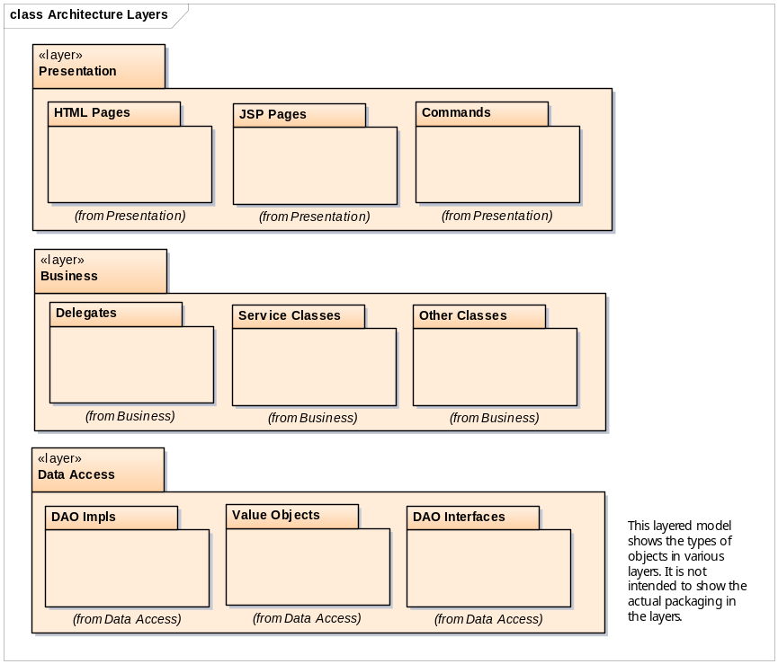

The following architectural decisions are made:
- The system is a web-based application with 3 layers: Presentation, Business and Data Access
- The Presentation Layer will be implemented using HTML/JSP Pages and Commands (with Java Servlet)
- The Business Layer will be implemented using Java classes
- The Data Access Layer will be implemented using JDBC with DAO pattern
- Data are persisted in a RDBMS

The following subsections capture the changes required to transition from analysis to design in terms of:
- Programming language
- Presentation Layer
- Data Access Layer
- Business Layer
- Invocation of Abstract Use Cases

Further subsections discuss strategies in dealing with the following nonfunctional requirements:
- Usability
- Performance, Reliability and Capacity
- Integrity
- Security
- Future growth

Programming Language
Java is the programming language of choice for PRMS.

Syntax
Unless otherwise specified, design and implemention should be performed following the coding convention captured in Java® Coding Style Guide found as IVLE’s /Workshops/Design Modeling/Java Coding Style Guide.pdf.

Packaging
The classes and interfaces for PRMS are packaged as follows.

Package (prefix: sg.edu.nus.iss.phoenix) | Description
.core | Non-use case specific
.core.controller | Non-use case specific business logic
.core.dao | Non-use case specific persistence logic
.core.exceptions | Non-use case specific exceptions
.authenticate | User authentication specific
.authenticate.controller | User authentication specific commands
.authenticate.dao | User authentication specific persistence logic
.authenticate.dao.impl | User authentication specific persistence implementation
.authenticate.delegate | User authentication specific business delegates
.authenticate.entity | User authentication specific value objects
.authenticate.service | User authentication specific business services
.radioprogram | Radio program specific
.radioprogram.controller | Radio program specific commands
.radioprogram.dao | Radio program specific persistence logic
.radioprogram.dao.impl | Radio program specific persistence implementation
.radioprogram.delegate | Radio program specific business delegates
.radioprogram.entity | Radio program specific value objects
.radioprogram.service | Radio program specific business services
.schedule | Schedule specific
.schedule.controller | Schedule specific commands
.schedule.dao | Schedule specific persistence logic
.schedule.dao.impl | Schedule specific persistence implementation
.schedule.delegate | Schedule specific business delegates
.schedule.entity | Schedule specific value objects
.schedule.service | Schedule specific business services
.user | User specific
.user.controller | User specific commands
.user.dao | User specific persistence logic
.user.dao.impl | User specific persistence implementation
.user.delegate | User specific business delegates
.user.entity | User specific value objects
.user.service | User specific business services

Object Lifecycle
A Java object is instantiated by calling its contructor with the new keyword. There is no need to deal with the destruction of object in Java. An instantiation interaction can be shown in sequence diagram using constructor name as message name.

If the instantiated object requires a reference to the instantiating object, it is generally realized by passing in the object reference of the instantiating object in the constructor of the instantiated object.

Multiple Inheritance
The analysis model has not made use of multiple inheritance. There is no need to address this issue here.

Presentation Layer
The User Interface of the PRMS system will be implemented using the Java EE. While it is possible to leave some of the details in this strategy to the programmer, it is assumed in this exercise that we wish to model the design till the “pages” of Java EE Web. We choose not to model the more granular components of Java EE Web, e.g. button, text field, etc. We will use the Nocturne Application Controller framework (discussed in the “Design for Web” lecture) and tiles for page layouts.

Impacted Analysis Objects
All the screen boundary objects are impacted. They translate into JSP pages to display information and accept user actions.

The layout is described in tiles.xml using the classic template (coded in classic.jsp). The layout is illustrated below:

m  e  n  u  .  j  s  p | header.jsp
m  e  n  u  .  j  s  p | body.jsp
m  e  n  u  .  j  s  p | footer.jsp

menu.jsp is formatted according to the role of the user (determined using sessionScope.user.roles variable).
A screen boundary object translates into a JSP Page with form action = “contextPath/nocturne/anAction”, for instance, login.jsp with form action = “${pageContext.request.contextPath}/nocturne/Login”. This page replaces body.jsp in the layout. The first screen will be home.jsp with Login menu item in menu.jsp.

All the control objects that interact with the screen boundary objects are impacted.

The analysis MainController translates into PhoenixFrontController servlet, which is the Nocturne Application Controller that maps HTTP requests to the corresponding commands (eg: LoginCmd command), using the Nocturne Action Map.

An impacted control object translates into a set of command objects that implements the Perform interface of Nocturne Application Controller framework. One user action is translated to one command object. The commands are responsible for only performing control logic corresponding to the user interface, such as displaying of pages, reception of user input, etc. The rest of the logic are placed in Business Layer objects. Commands interact with Business Layer objects via their corresponding delegate objects.

Impacted Use Cases
All the use cases that perform user interaction are impacted. For examples, Maintain Radio Programs and View Program Details use cases.

Transition of Static Structure
The following class diagram illustrates the static structure of the design.
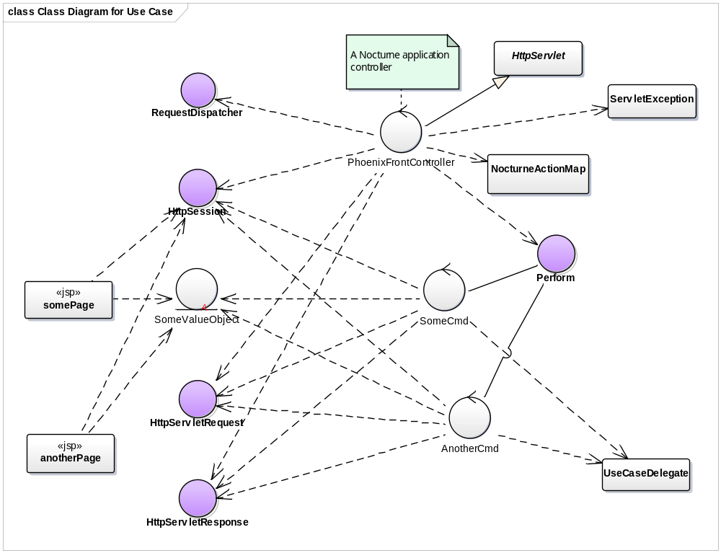

Transition of Dynamic Interactions
The following sequence diagram illustrates the dynamic interactions for a HTTP request and the corresponding HTTP response.
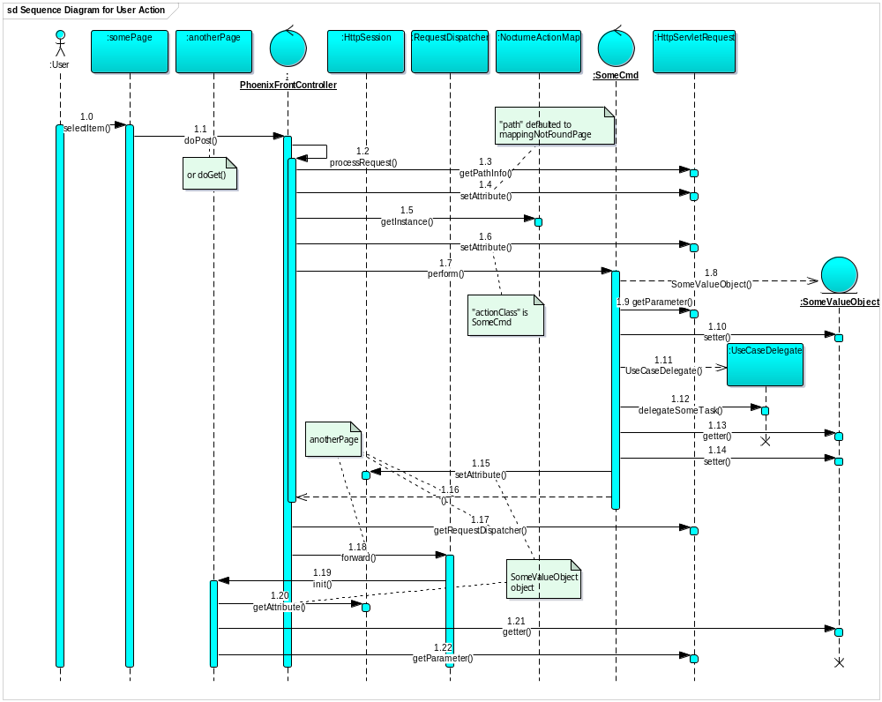

Data Access Layer
The Persistence Layer for PRMS is abstracted using the Data Access Object (DAO) design pattern. The implementation of CRUD operations is done using JDBC APIs.

Impacted Analysis Objects
All the persistent entity objects are impacted. All the boundary, control and entity objects that interact with persistent entity objects are also impacted.

Impacted Use Cases
All the use cases that perform data persistence operations are impacted. For examples, Maintain Radio Programs and View Program Details use cases.

For each entity class, that needs to be persisted, a separate DAO with the required CRUD (Create, Retrieve, Update and Delete) operations is introduced. It is assumed that the relationships such as 1-many, 1-1, many–many, etc. will be taken care of outside the Data Access Layer. Hence the integrity of such relationships is the responsibility of the Business Layer classes. However, the Value Objects have to reflect these relationships.

Every DAO must implement an interface similar to the interface shown below. One DAOImpl class that implements this interface should be provided for every DAO interface. This class must implement all the methods using JDBC APIs. Every ValueObject class associated with any DAO must implement the Cloneable and Serializable interface.
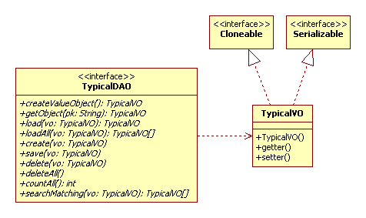

Transition of Static Structure
The following class diagram illustrates the static structure of the design. For simplicity, the design class diagram may omit JDBC classes if it does not deviate from this guideline.

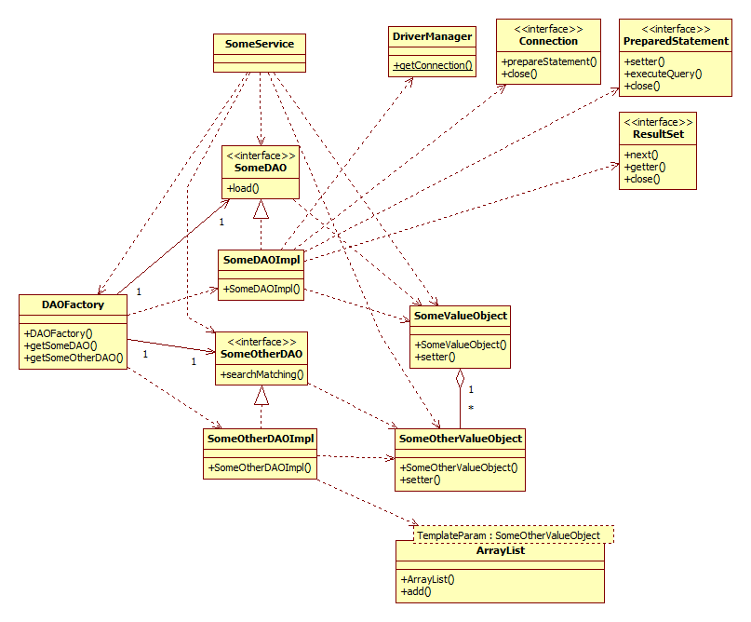

Transition of Dynamic Interactions
The following sequence diagram illustrates the typical dynamic interactions of the design for the retrieval of a whole object and its part objects with 1-many relationship. For simplicity, the design sequence diagram may omit JDBC objects if it does not deviate from this guideline.
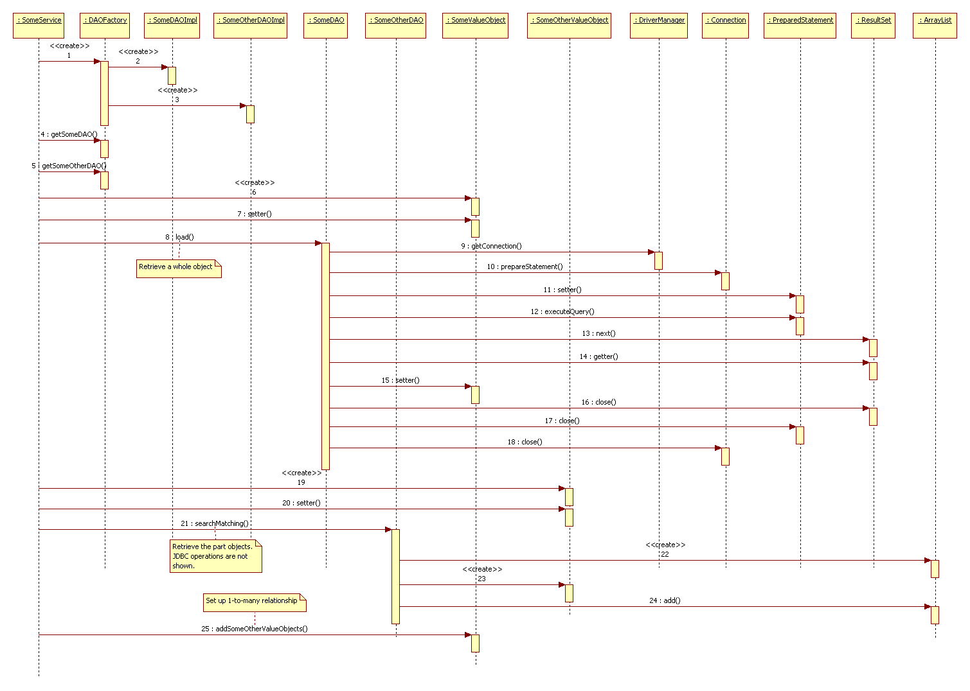

Business Layer
The Business Layer for PRMS is implemented as a glue between the Presentation and Data Access Layers. Any business logic (excluding UI logic) that requires manipulating data or otherwise (flow control and business logic) are encapsulated in this layer. Typically, classes in this layer will make use of one or more DAO classes (using the DAO interface).

Classes in Presentation Layer (in this case the controller servlets) interact with the Business Layer classes using the Business Delegate design pattern.

Impacted Analysis Objects
All the control objects that encapsulate business logic and/or interact with persistent entity objects are impacted. Note that the flow logic for interacting with the boundary objects are kept in the command objects. All screen boundary objects that interact with such control objects are also impacted.

An impacted control object is translated to a pair of use case-specific delegate and service objects. For instance, AuthenticateDelegate and AuthenticateService for the Authenticate Users use case.

A screen boundary object that interacts with such a control object invokes the latter’s business logic via the latter’s delegate object.

Impacted Use Cases
All the use cases that perform business logic and/or involve data persistency are impacted. For examples, Maintain Radio Programs and Review/Select Radio Program use cases.

Transition of Static Structure
The following class diagram illustrates the static structure of the design.

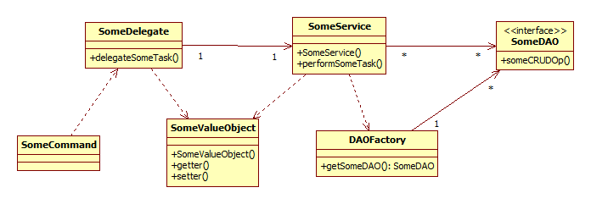

Transition of Dynamic Interactions
The following sequence diagram illustrates the typical dynamic interactions of the design for performing a task delegated by Presentation Layer and accessing Data Access Layer.

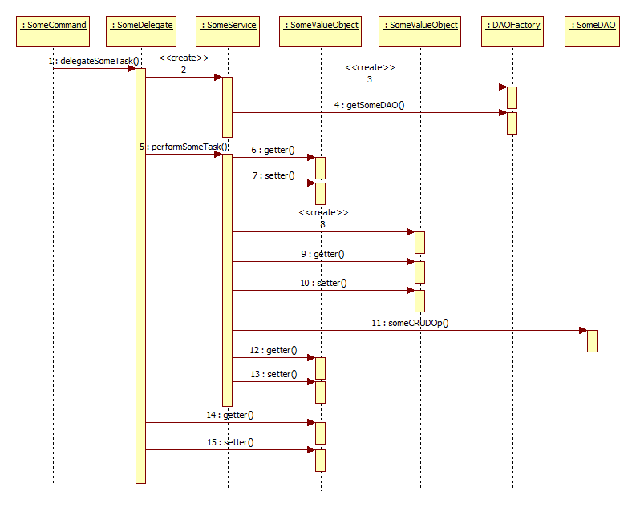

Invocation of Abstract Use Cases
The flow logic of a use case spreads across the command and service objects. This section specifies the strategy for a base use case to invoke an inclusion/extension use case and return from it.

Impacted Analysis Objects
All the control objects of base and inclusion/extension use cases are impacted.

A pair of impacted base and inclusion/extension control objects work closely for the invocation. A command object of the base use case invokes an inclusion/extension use case by calling the latter’s delegate and service objects. The command object decides on the URL of the page to forward to: a page in the base use case effectively returns the flow back to the base use case; a page in the inclusion/extension use case effectively keeps the flow in the latter.

Impacted Use Cases
All the base and inclusion/extension use cases are impacted. For examples, Maintain Radio Programs and Review/Select Radio Program use cases.

Transition of Static Structure
The following class diagram illustrates the static structure of the design.
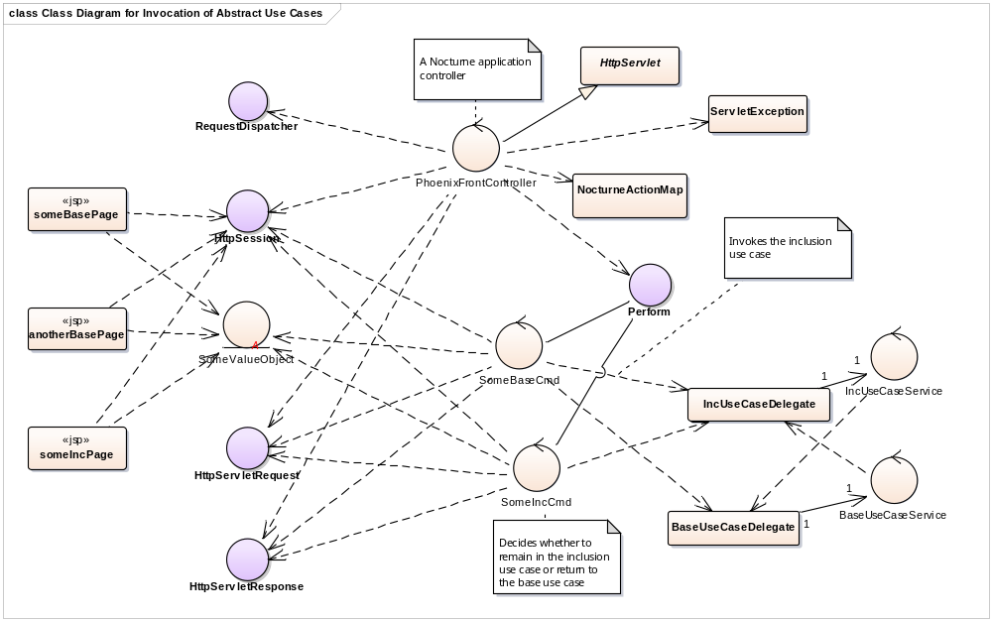

Transition of Dynamic Interactions
The following sequence diagram illustrates the typical dynamic interactions of the design for performing a task delegated by Presentation Layer and accessing Data Access Layer.
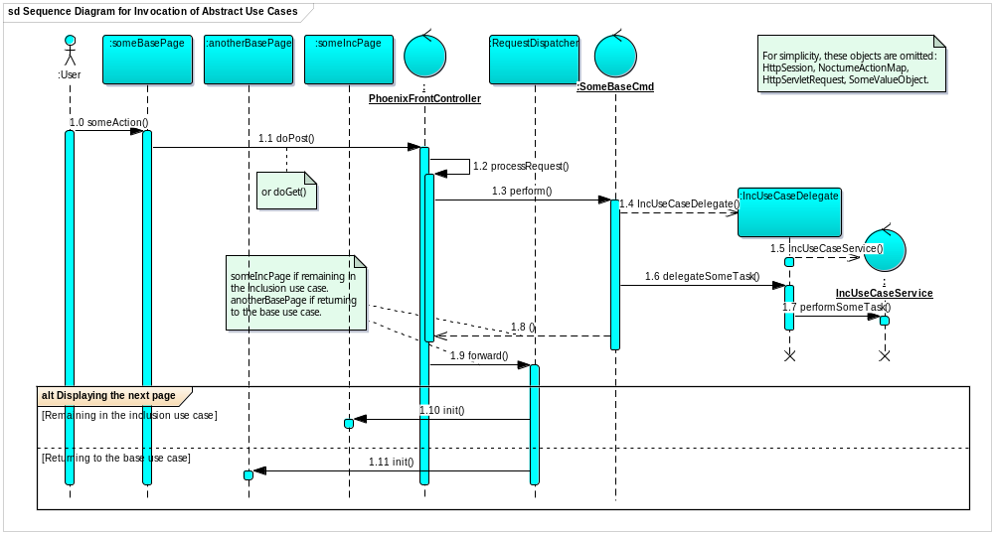

Usability
The usability of PRMS is fulfilled using web-based user interface as designed in the above subsection on Presentation Layer.

Performance, Reliability and Capacity
By using Java EE 6 platform, these nonfunctional requirements are deemed to have no impact on software design. They will be fulfilled via system configuration of hardware and platform.

Integrity
The integrity of playlist is realized via View Playlist Audit Trail and Undo Modify/Delete use cases.

Security
The security of PRMS is realized via Authenticate Users and Maintain Users use cases.

Future Growth
The potential impact of changing persistence mechanism is reduced using DAO design pattern. The potential impact of adding/removing JSP pages is reduced using Front Controller design pattern in Presentation Layer. The potential impact of tight coupling between Presentation and Business Layers is reduced using Business Delegate design pattern.

Deployment
Given that PRMS is a continuous assessment for Unit 3, it will be deployed on a standalone desktop PC running Windows 7 for testing.

